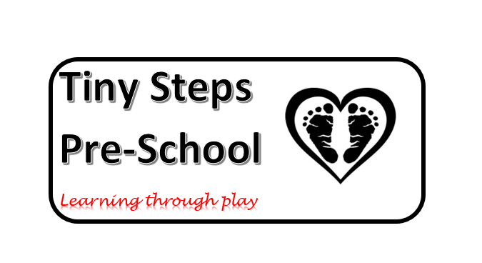

**Our Curriculum Intent and Teaching Pedagogy**

“We do not stop playing because we grow old. We grow old because we stop playing.” George Bernard Shaw

“Play strengthens instincts needed for the future….it is a child’s way of practising and preparing for adulthood.” Kathy Sylva, 1992

We believe children learn best when experiences are first-hand and linked to their interests. We value play and the powerful opportunities it provides for children to build upon previous leaning in a meaningful and purposeful way. Our curriculum is based on the principles of the Foundation Stage, providing a smooth transition for children as they continue their journey into Year R and continues to build upon their prior knowledge and experiences. Our curriculum places a high emphasis on basic skills, to ensure they are equipped with the necessary skills for life whilst providing active learning, ensuring children are engaged and motivated at all times. We provide opportunities for children to consolidate skills and make links in their learning. Continuous provision encompasses a range of activities and different approaches to learning to meet the diverse learning styles children have. By learning this way, we foster and encourage independence to enable children to “learn how to learn” and want to continue to learn on their journey through life.

Due to recent curriculum changes from the Department for Education, we have reassessed how we plan for your children and the skills we are looking to teach, model, support and extend throughout their time here.

Keyworkers will be focusing on skills rather than end products, which may result in less work being brought home but will mean they have the skills to make lots of amazing things independently.

Language will be imbedded into every aspect of our practice to ensure children are hearing lots of quality exchanges, back and forth interactions and are surrounded by a language rich environment. Children with English as an additional language (EAL) will be supported by their keyworkers who will work closely with families to ensure written examples of their home language are included in the setting. Parents will be asked for a small list of commonly used words in children’s home language and we will go through these to ensure pronunciation is correct. Our mat times will include welcomes in any additional language used by our children. We use lots of rhymes and songs with gestures and Makaton to make sure this fun time is inclusive to all children.

We have 10 overarching goals set out for this current 2022 cohort to achieve, throughout the year we will build, develop and embed the skills needed to reach these targets.

Targets are chosen so that every area of the Early Years Framework is addressed, with the aim of children going to school with vital skills and knowledge to help them with their future education.

Targets are based around 7 areas of Learning these are:

* Personal, Social and Emotional Development.
* Communication and Language
* Physical Development
* Mathematics
* Literacy
* Expressive Arts and Design
* Understanding the World

Tiny Steps Preschools 10 overarching goals are:

* Build a den with their peers
* Lead part of mat time/ song time
* Make a book
* Use a familiar story/poem/ to put on a show
* Make a 3D model
* Draw/ Paint a self portrait
* Make and decorate a fairy cake
* Grow and care for a plant or Vegetable
* Design and set up an Obstacle course
* Add to preschool floor book

All of these goals support skills that will enable children to begin reading, writing, questioning, observing, building, baking, acting, growing and moving. It will provide a strong scaffold to build skills needed for their future learning as well as encouraging their self-belief, confidence and interests in the world around them.