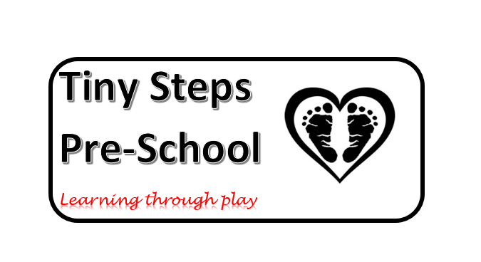
Tiny Steps sessions and price list
2 year old pricing and sessions
Session | Price
9-12 | £24
9-1 | £32
9-3 | £48
9-3.15 | £50
12-3 | £24
12-3.15 | £26
2 year old prices are based on hourly fees of £8
3 year old pricing and sessions
Session | Price
9-12 | £22.50
9-1 | £30
9-3 | £45
9-3.15 | £46.88
12-3 | £22.50
12-3.15 | £24.38
3 year old prices are based on hourly fees of £7.50

