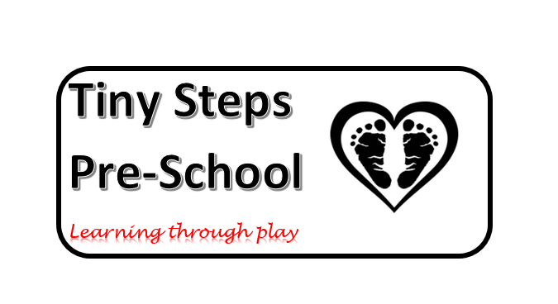

Covid 19 Health and Safety Policy

During this difficult time and for the foreseeable future Tiny Steps Preschool have put in to place a variety of actions to ensure a safer return to us on June the 1st should we be given the all clear on the 28th May.
The safety of the children in our care is and has always been our highest priority for this reason we would ask you to ensure you follow the following guidance in relation to preschool.
Parents/Carers Actions
- Children will NOT be allowed to bring in any toys from home.
- Buggies will NOT be able to be left in the hallway until further notice.
- Children will bring in lunchboxes and drinks as required, this is the only thing permitted in so please ensure any medication, nappies and wipes are also in there.
- Please DO NOT ring the doorbell, staff will open the door at the beginning of sessions to let your children in, please be patient as we will be bringing children in one at a time, or in family groups if siblings.
- At this time parents will NOT be allowed in the preschool, please email or phone with any queries so as not to delay drop off or collection for other parents.
- Children will arrive at the front door as usual, this will be marked with a start point and distances to make it easier to wait, we are using coloured spots which might help the children wait in place too.
- Children will be collected from the gate of the back garden, again we will mark 2 metre spaces for you, please be patient and allow the family in front to move away before stepping forward.
- Please do not give Calpol before preschool as it marks symptoms, if your child needs Calpol they should not be in preschool.
- If a family member is showing ANY Covid 19 symptoms we will expect your child to be kept at home for 14 days.
- Tests are available for children or parents of children, who are attending Preschool.

Preschool/staff actions

- Preschool places have been capped at 10 per session to enable us to split them into smaller groups for lunch and group times.
- We will reduce the gathering of parents and children by bringing children in one at a time minimising ‘pinch points’. We will also let children start sessions from the front of the hall and finish from the back garden, this will again reduce number of parents waiting.
- Our outdoor space will be used as much as possible with weather permitting and we will provide children with sun cream for the rest of this term.
- We will mark out the waiting areas at the front and back of preschool making spaces clear and measuring 2 metres apart.
- Children and staff will wash and use gel on their hands upon entry to preschool as well as at key points throughout the day and before group activities.
- We will be using a non-contact forehead thermometer to check temperature’s on ALL children on arrival and children will be excluded for 14 days if they have a high temperature.
- Preschool wont currently be making things to go home however we will add lots of pictures on our Facebook page with what the children have done as well as on Tapestry. https://www.facebook.com/tinystepspreshoolbasingstoke
- If your child is starting school in September they will still receive a Transition report which you will receive a copy of.
- We will exclude any child showing symptoms including a cold, for 14 days.
- Drinks and lunch boxes will be wiped down with antibacterial wipes on arrival.
- Craft resources like playdough and tools will be kept in individual children’s drawers.
- Reduced sessions will enable staff to clean all resources including toys, table’s and chairs. Door handles will be cleaned between sessions.
- The hall will be cleaned thoroughly every day.
- Preschool are currently the only people using the hall which also helps with minimising contamination.

Please be mindful that staff also have their own children and families at home and for this reason, and to keep your own children as safe as possible, please follow the above guidance. Thank you.

