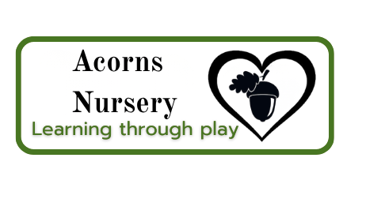
Tiny Steps sessions and price list
2 year old pricing and sessions
Session | Price
9-12 | £25.50
9-1 | £34
9-2 | £42.50
9-3 | £51
9-4 | £59.50
12-3 | £25.50
12-4 | £34
2 year old prices are based on hourly fees of £8.50
3 year old pricing and sessions
Session | Price
9-12 | £24
9-1 | £32
9-2 | £40
9-3 | £48
9-4 | £50
12-3 | £24
12-4 | £32
3 year old prices are based on hourly fees of £8.00

